color_space = 'RGB' # Can be RGB, HSV, LUV, HLS, YUV, YCrCb

orient = 11 # HOG orientations

pix_per_cell = 12 # HOG pixels per cell

cell_per_block = 4 # HOG cells per block

hog_channel = "ALL" # Can be 0, 1, 2, or "ALL"

spatial_size = (18, 18) # Spatial binning dimensions

hist_bins = 32 # Number of histogram bins

spatial_feat = True # Spatial features on or off

hist_feat = True # Histogram features on or off

hog_feat = True # HOG features on or off

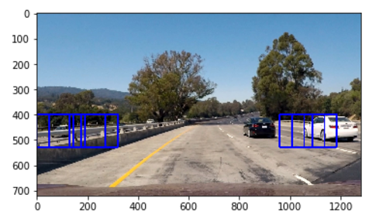

color_space = 'HSV' # Can be RGB, HSV, LUV, HLS, YUV, YCrCb

orient = 11 # HOG orientations

pix_per_cell = 12 # HOG pixels per cell

cell_per_block = 4 # HOG cells per block

hog_channel = "ALL" # Can be 0, 1, 2, or "ALL"

spatial_size = (18, 18) # Spatial binning dimensions

hist_bins = 32 # Number of histogram bins

spatial_feat = True # Spatial features on or off

hist_feat = True # Histogram features on or off

hog_feat = True # HOG features on or off

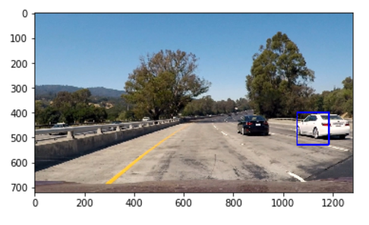

color_space = 'LUV' # Can be RGB, HSV, LUV, HLS, YUV, YCrCb

orient = 11 # HOG orientations

pix_per_cell = 12 # HOG pixels per cell

cell_per_block = 4 # HOG cells per block

hog_channel = "ALL" # Can be 0, 1, 2, or "ALL"

spatial_size = (18, 18) # Spatial binning dimensions

hist_bins = 32 # Number of histogram bins

spatial_feat = True # Spatial features on or off

hist_feat = True # Histogram features on or off

hog_feat = True # HOG features on or off

#y_start_stop = [450, 720] # Min and max in y to search in slide_window()

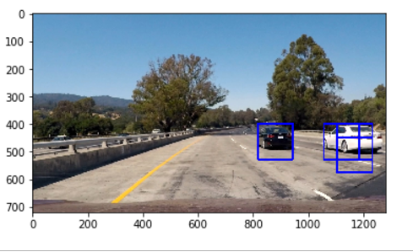

color_space = 'HLS' # Can be RGB, HSV, LUV, HLS, YUV, YCrCb

orient = 11 # HOG orientations

pix_per_cell = 12 # HOG pixels per cell

cell_per_block = 4 # HOG cells per block

hog_channel = "ALL" # Can be 0, 1, 2, or "ALL"

spatial_size = (18, 18) # Spatial binning dimensions

hist_bins = 32 # Number of histogram bins

spatial_feat = True # Spatial features on or off

hist_feat = True # Histogram features on or off

hog_feat = True # HOG features on or off

#y_start_stop = [450, 720] # Min and max in y to search in slide_window()

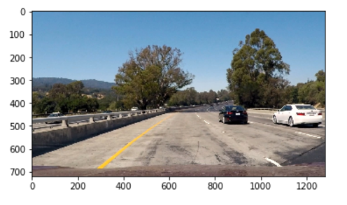

color_space = 'YUV' # Can be RGB, HSV, LUV, HLS, YUV, YCrCb

orient = 11 # HOG orientations

pix_per_cell = 12 # HOG pixels per cell

cell_per_block = 4 # HOG cells per block

hog_channel = "ALL" # Can be 0, 1, 2, or "ALL"

spatial_size = (18, 18) # Spatial binning dimensions

hist_bins = 32 # Number of histogram bins

spatial_feat = True # Spatial features on or off

hist_feat = True # Histogram features on or off

hog_feat = True # HOG features on or off

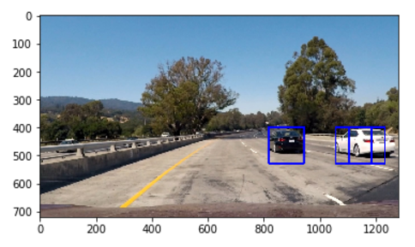

color_space = 'YCrCb' # Can be RGB, HSV, LUV, HLS, YUV, YCrCb

orient = 11 # HOG orientations

pix_per_cell = 12 # HOG pixels per cell

cell_per_block = 4 # HOG cells per block

hog_channel = "ALL" # Can be 0, 1, 2, or "ALL"

spatial_size = (18, 18) # Spatial binning dimensions

hist_bins = 32 # Number of histogram bins

spatial_feat = True # Spatial features on or off

hist_feat = True # Histogram features on or off

hog_feat = True # HOG features on or off

